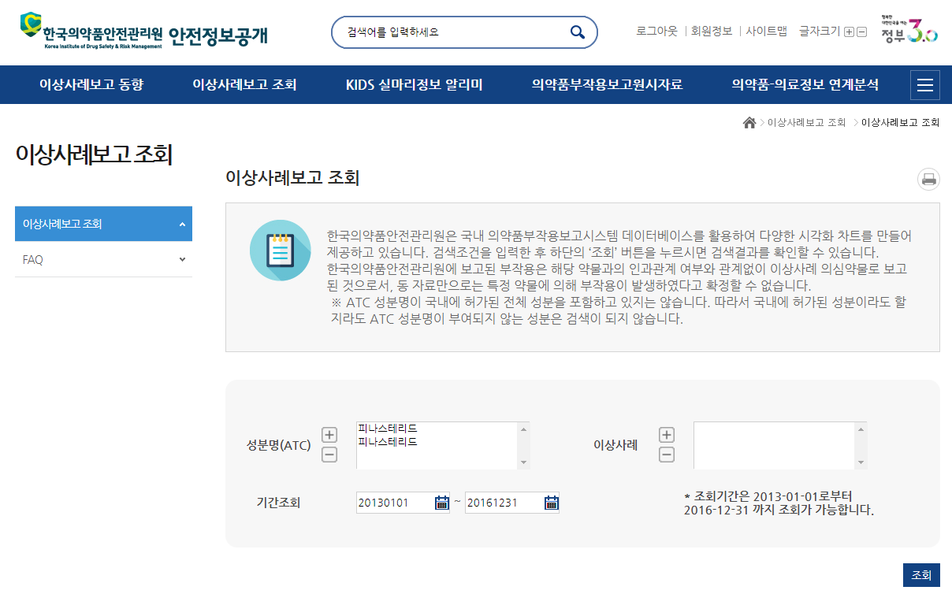

**Search**

Home > ADR Report Search > ADR Report Search

The available search period is from 2013-01-01 until 2016-12-31.

Search Period

ADR Case

Fina Steride

Finasteride

ATC (ATC)

The Korea Institute of Drug Safety and Risk Management provides a variety of visualized charts utilizing the data base of the domestic pharmaceutical side effects report system. Please enter the search criteria and click the "Search" button below to see the results. Please note that these ADRs were simply reported to this Institute regardless of their relevance to the specific side effect and we cannot confirm that a side effect occurred by taking the specific drug based on this data.

* The ATC Element below doesn't contain the entire elements approved in Korea. So you won't be able to find any data without entering a specific "ATC Element" in the search area.

ADR Report Search

ADR Report Search

ADR Report Search

**ADR Report Trends ADR Report Search KIDS Clue Info Alarm Original Data of Pharmaceutical Side Effect Report Drug-Medical Info Analysis**

Log Out I Member Info I Site Map I Font

Enter Keyword

KIDSRM

Publication of Safety Information

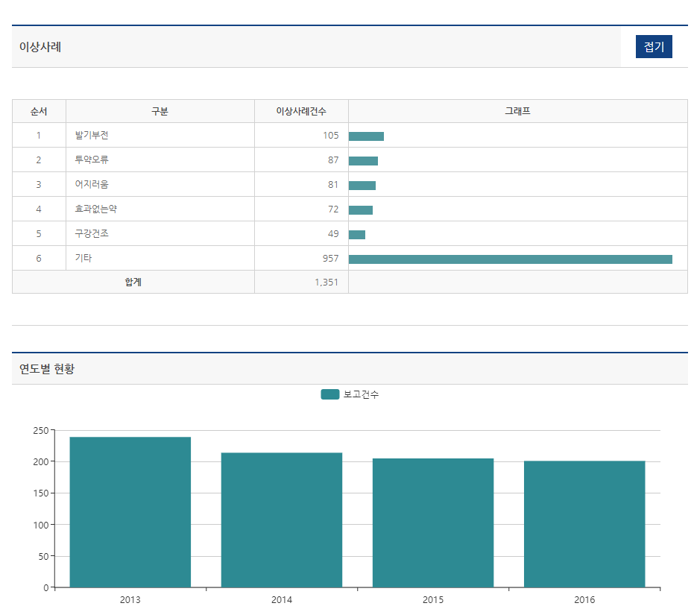

Number of Reported Cases

Total

Others

Dry Mouth

No Effect

Dizziness

Medication Error

Erectile Dysfunction

Graph

# of Cases

ADR

No.

**Hide**

Type of ADRs

# of Reported ADRs for the Respective Years

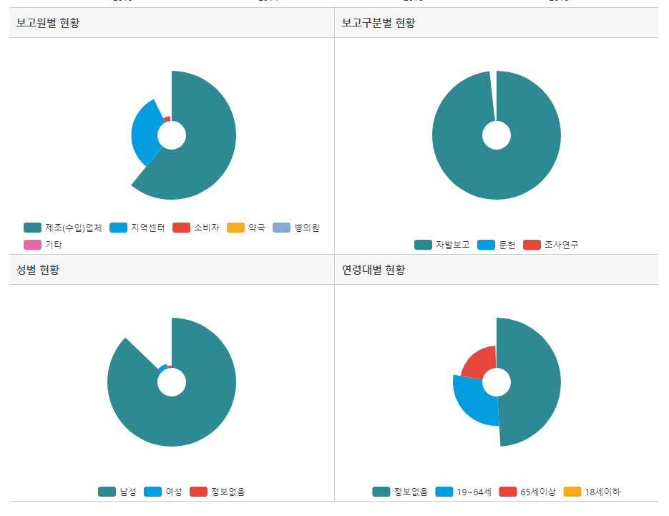

Older than 65

Age 19~64

No information available

Female

Male

Publication

Voluntary Report

Manufacturer (Importer)

Clinic

Others

Pharmacy

Consumer

Local Medical Center

Younger than 18

No information available

Research & Development

Age Group

Gender

Type of Report

Source